**DIY Flex Layout**

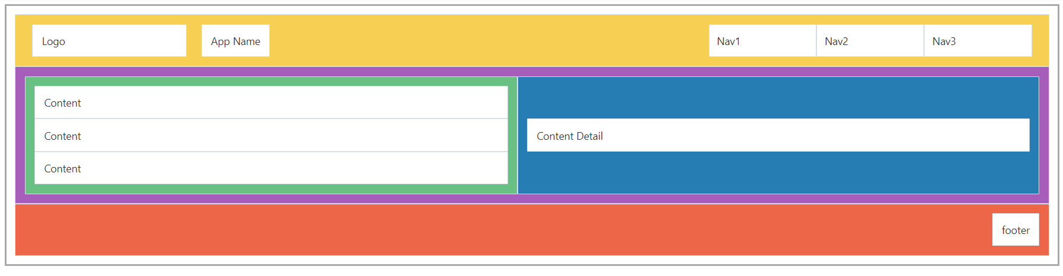The flex layout is used to create a page layout that is flexible and responsive. Go to the Layout section in the JET Cookbook to discover more about the Flex Layout. Use the JS Doc, there you will find the different classes that can be used for flexibility and alignment. In this exercise you will use the different classes from Flex Layout, Grid Layout and oj-panels (also found in the Layout section of the Cookbook) to create the following design:

A few things before you start:

* Don’t worry about content, it’s more important that all panels are in the right place.
* Give the panels different colors so you can tell them apart (use css with id-selectors).
* The headerpanel also uses the Grid Layout - 12 column principle and flex-item padding.
* Not all oj-flex divs have oj-flex-items.
* The design contains 16 panels.

**Additional**

* Change the size of the browser or device (possible in the browser dev tools – F12) to see how the panels respond to size changes.
* Play around with the classes in the code to see how the panels respond.
* Fun when you’re done: <https://flexboxfroggy.com/>

**Result: Project LayOut on Github**